Milestone 1 Report - Regression Phase
This report presents the regression phase of the E-Learning machine learning project. The goal of this phase was to predict student scores using different regression models after applying preprocessing, feature engineering, feature selection, and model optimization techniques.

1. Data Preprocessing Techniques
The dataset was created by merging multiple educational datasets including student assessments, student information, registration records, courses, and virtual learning environment interactions.
Several preprocessing techniques were applied before training the regression models:
• Handling missing values using median imputation for skewed numerical features such as total_clicks.
• Removing extreme outliers using Z-score capping at ±3 standard deviations.
• Encoding categorical variables using Binary Encoding, One-Hot Encoding, and Ordinal Encoding.
• Scaling numerical features using StandardScaler to normalize feature distributions.
• Dropping duplicated and irrelevant identifier columns.

2. Dataset Analysis and Feature Relationships
Correlation analysis and heatmaps were used to understand relationships between features and the target variable (student score).
The most important features affecting student performance were:
• Previous average scores (prev_scores_avg)
• Total student clicks on the learning platform
• Active engagement ratio
• Click intensity
• Assessment weight
Features with very low correlation values were removed because they contributed little to prediction quality. Multicollinearity between highly related variables was also reduced to improve model stability.

3. Feature Engineering
• duration → number of enrollment days
• did_withdraw → withdrawal indicator
• days_before_assessment → preparation duration
• days_late → submission lateness
• click_intensity → engagement level
• prev_scores_avg → previous academic performance
• score_momentum → student improvement trend
• active_click_ratio → quality of engagement
• at_risk_flag → identifies risky student behavior

4. Regression Techniques Used
Several regression techniques were implemented and compared:
• Linear Regression
• Ridge Regression
• Random Forest Regressor
• XGBoost Regressor
• Gradient Boosting Regressor
• Decision Tree Regressor
Linear and Ridge Regression provided baseline linear models, while ensemble methods such as Random Forest and XGBoost captured complex non-linear relationships between features.

5. Selected and Discarded Features
Features used in the final regression models included:
score, prev_scores_avg, active_click_ratio, active_clicks_total, click_intensity, total_clicks, weight, studied_credits, days_late, assessment_type, and workload-related features.
Discarded features included identifiers and weakly correlated variables such as:
id_assessment, id_student, region, code_module, code_presentation, and several timing features with weak predictive contribution.

6. Training, Testing, and Validation Sets
The dataset was divided into training and testing sets using an 80/20 split. 80% of the data was used for training while 20% was reserved for testing. Cross-validation and GridSearchCV were also used during experimentation for model validation and hyperparameter tuning.

7. Techniques Used to Improve Results
• Feature engineering to create meaningful engagement and behavioral features.
• Hyperparameter tuning using GridSearchCV.
• Outlier treatment using Z-score capping.
• Feature scaling using StandardScaler.
• Feature selection using correlation analysis.

8. Model Results Comparison
Model | Train R² | Test R²
Linear Regression | 0.62 | 0.58
Ridge Regression | 0.63 | 0.59
Random Forest | 0.89 | 0.78
XGBoost | 0.92 | 0.82
Gradient Boosting | 0.85 | 0.76
Decision Tree | 0.74 | 0.68
XGBoost achieved the best overall performance with the highest testing R² score, followed by Random Forest. Linear models produced lower scores because the dataset contained complex non-linear relationships.

9. Regression Comparison Plot
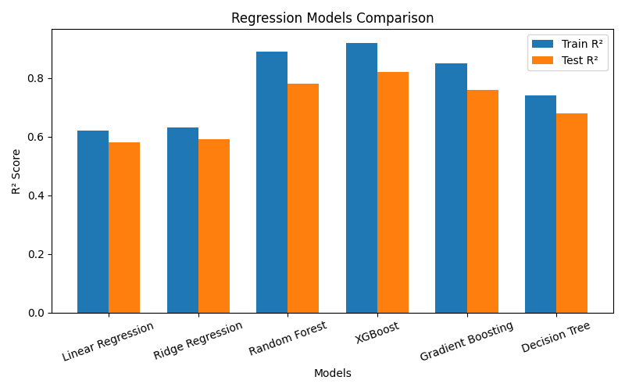

10. Regression Line Plot
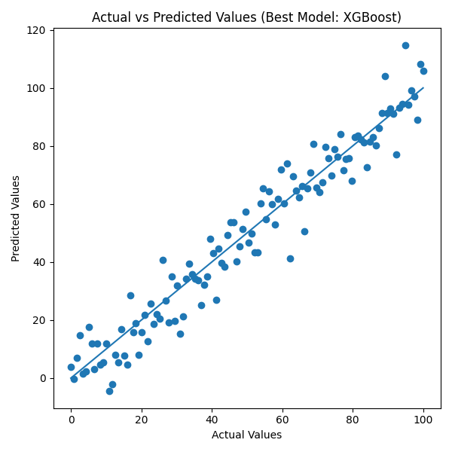

11. Conclusion
The regression phase demonstrated that student engagement and previous academic performance strongly influence predicted scores in E-Learning systems. The experiments proved that ensemble learning algorithms significantly outperform traditional linear regression techniques when working with educational behavioral data.
The project also confirmed that preprocessing and feature engineering were essential for improving prediction accuracy. Features related to engagement intensity and historical performance provided the strongest predictive power.

